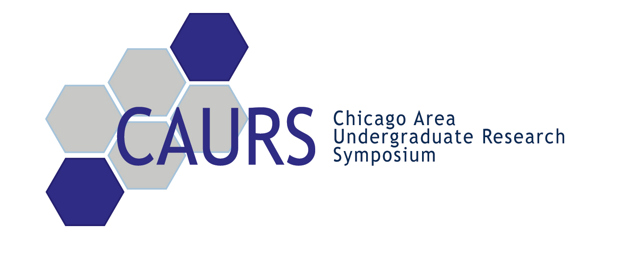

Thank you again for you dedication and commitment to the 5th annual
Chicago Area Undergraduate Research Symposium!

We are looking forward to seeing you this Saturday, April 18, 2009!

Robert H. Lurie Cancer Center
Northwestern University School of Medicine
303 E. Superior
Chicago, IL 60611

You will be assigned to judge specific students ahead of time and will receive this list of students upon arrival. There are over 150 students participating in this event and it is important that they are all given the opportunity to receive feedback from the distinguished academic judges. It is very important that you attend the event during your scheduled time—the students are counting on you!

Schedule updates: Our full event schedule can be found on page 2.
- We will be holding a brief orientation meeting for our judges before each judging session at 11:15am, 1:30pm, and 3:45pm in Baldwin Auditorium to answer any questions you may have about the event.

Transportation:
Public Transportation:
We strongly encourage you to use public transportation. The Grand and Chicago stops on the Red Line, as well as many bus routes, are both within a few blocks from Robert H. Lurie Cancer Center. Please see the map of the Northwestern University downtown campus on page 3.

Driving & Parking:
CAURS will be also providing free parking for our judges. You can park in one of two garages: 1) the corner of Superior and St. Clair or 2) the corner of Fairbanks and Erie (see map – page 3). You may pick up a parking voucher at the registration tables.

Event details:
- Oral presentations are split into five rooms. The oral presentations have been divided by subject. You are encouraged to ask the students questions!
- Catered box lunches will be served in Jazzman’s Café – Lurie Cancer Center. You are free to eat lunch there or visit local restaurants. Please be back in time for the oral presentations.
- Dinner arrangements have been reserved according to your attendance as specified in your registration form. If you are not staying for the banquet, you are still encouraged to listen to the keynote lecture by Dr. Shannon Hackett, Associate Curator at the Field Museum of Natural History and Head of the Division of Birds, in the Main Ballroom in Weiboldt Hall.
- Awards will be given for the top poster presentations in each subject, top oral presentation, and the best overall presentation. Award-winning students will receive prizes of up to $500 to put towards future research.

This is a business professional event

Please email info@caurs.com or visit our website at www.caurs.com if you have any questions.
Thank you and see you this Saturday, April 18, 2009!

